School Board of Levy County

REQUEST FOR PROPOSAL

Internet Access Services

Bid Number: 19-07

Thomas Bennett
Director, MIS/IT
480 Marshburn Drive
Bronson, FL 32621

School Board of Levy County

INVITATION TO BID (ITB)
19-07

SECTION I

INTRODUCTION

  - GENERAL INFORMATION

The School Board of Levy County (hereinafter referred to as “The Customer”) is in need of procuring a connection to the Internet which will provide access to the desktop level for all schools and other locations in the district. The Customer herein requests proposals for these services as described in the attached specifications from interested persons (hereinafter known as “The Vendor”). The Vendor must submit a bid for all areas and show an integrated approach with respect to hardware, services and support. Prices quoted shall be all inclusive. The Customer reserves the right to reject any and all proposals, waive any technicalities and award all or part of the contract in a manner that is in the best interest of the School Board of Levy County.

These services will meet the Federal Communication Commission (FCC) definition of “leased services” (paragraph 193 of FCC’s fourth Order of Reconsideration).

All aspects of this project must comply with the Federal Communication Commission’s competitive bidding requirement for Universal Service Fund (USF) support and services.

All upfront Capital Costs must be clearly delineated

Vendor must be a certified Internet/Telecommunication Provider with the SLD.

Contact Person for this ITB is:
Thomas Bennett
Director, MIS/IT
480 Marshburn Drive
Bronson, FL 32621
352.486.5231
thomas.bennett@levyk12.org

This ITB and the successful Proposer’s response will be made part of any contract awarded from this ITB
The Board reserves the right to accept or reject any or all proposals.

School Board of Levy County

INVITATION TO BID (ITB)
19-07

  - SCHEDULE OF EVENTS

The following is the required schedule of events for the project. The schedule may change depending on the results of the responses and a final schedule will be established prior to contracting with the successful vendor.

Event | Date
- Release of ITB to Bidders | 29 October 2019
- Deadline for Proposal submission | 3 December 2019 2:00 PM
- Bid Award Letter | To Be Determined
- Installation Begins | Upon contract award date by the School Board of Levy County
- Installation Completed | Internet Access should be in place and operational by July 1, 2020**
** Because e-rate funding runs from July 1st of each year, failure to have services installed and running by that date will cause the district to be faced with un-E-ratable, unrecoverable costs. Therefore, every effort should be made to ensure services are in place by July 1, 2020.

  - CURRENT SYSTEM AND CONNECTIVITY LOCATIONS

The School Board of Levy County is presently using a 1 Gbps connection provided by AT&T. The School Board of Levy County is interested in upgrading these services. The connection comes into the District office of the School Board at 480 Marshburn Drive, Bronson, FL 32621.

School Board of Levy County

INVITATION TO BID (ITB)
19-07

SECTION II

INTERNET CONNECTIVITY AND INTEGRATED SERVICES

2.1 INTERNET CONNECTIVITY

Vendor must provide Internet Services, 2 Gbps or higher fiber-based connection to the District Office. It is anticipated that the school district needs for addition Internet access bandwidth will expand in the future. Please provide for consideration pricing for 2 Gbps, 3 Gbps and 4 Gbps.

2.2 INTERNET ACCESS CONFIGURATION

Vendor must supply survey, design, procurement, and configuration of the Internet Access. This configuration includes obtaining all permits, zoning requests, and inspections required by law, statute, or ordinance. Internet services are to be installed at the MIS office with the demarc of vendor’s services to be provisioned on an Ethernet interface provided by the vendor at the Customer’s designated demarc.

2.3 INTEGRATED SERVICE SOLUTIONS

Vendor must provide (at no additional cost), any and all Integrated Service Solutions that are inherent functions of its network.

SECTION IIII

MAINTENANCE, SUPPORT SERVICES, AND TRAINING

3.1 24 X 7 PROACTIVE MONITORING SERVICES

Vendor should provide proactive monitoring of its infrastructure components at all times.

School Board of Levy County

INVITATION TO BID (ITB)
19-07

3.2 TROUBLE TICKETING SERVICES

Vendor must provide a trouble ticketing system, available via a Web Interface, for district technical personnel to report issues and track resolution status. A toll-free number to the monitoring center shall also be provided.

3.3 DISPATCH SERVICES

Vendor must provide dispatch support services for maintenance of its infrastructure equipment. These dispatch services should occur within four (4) hours of notification of a failure in an infrastructure equipment component. Vendor must have field Technicians to repair/replace/support vendor owned and supplied switches and other equipment necessary to provide the needed service

3.4 TRAINING

One day of training for key personnel on the systems; covering the following topics:

- Support procedures and escalation processes
- Reporting and Monitoring

SECTION IV

VENDOR QUALIFICATIONS

4.1 VENDOR REFERENCE LIST

Bidding vendors must provide a reference list of schools where they have prior experience with providing Internet Access as defined by the Schools and Libraries Division and where successful E-rate applications were funded.

School Board of Levy County

INVITATION TO BID (ITB)
19-07

4.2 VENDOR EXPERIENCE

Vendors must give at least three (3) examples of experience with installation of medium to large scale sites that have equal Internet connectivity services (1 Gbps or greater); at least one of these examples must be similar in size and scope to the requirements of this ITB. The Customer may, with the full cooperation of the Vendor, visit client installations to observe equipment operations and consult with references. Specified visits and discussions shall be arranged through the Vendor

SECTION V

TERMS AND CONDITIONS OF INVITATION TO BID

5.1 RESPONSE SUBMISSION

Responses to this ITB must be submitted in a sealed package and delivered Brandon Eastman,
Purchasing Agent, School Board of Levy County, 480 Marshburn Drive, Bronson, FL 32621 no later than 2:00 PM ET on December 3, 2019, so that this bid is in compliance with the Federal Communication Commission’s competitive bidding requirement for Universal Service Fund (USF) support and services. It is the sole responsibility of the respondents to ensure that their responses arrive in a timely manner. The Customer will reject all late arrivals. The vendor must submit one (1) original of the response, plus one signed copy, along with any required supporting documentation. A digital/electronic copy of the complete proposal and supporting documentation must also be provided on CD/DVD and flash drive. “Response to ITB 19-07 – Sealed Bid” should be clearly marked on the face of the envelope containing the bid. Failure to comply with this may cause the bid to be misdirected and, therefore, not to be considered. Responses must be for the entire project. No substitutions or partial bids will be allowed. Oral, telephone, faxed, or telegraphed bids shall not be considered, nor will modifications of bids by such communication be considered. The completed bid form shall be without erasures or
alterations. Signatures on the proposal shall be in longhand and executed by an individual duly
authorized by the Vendor to make a contract. Bids made out in pencil will NOT be accepted. Bid must be notarized. Prior to commencement of work, Vendor will name lessee as an additional insured for liability
purposes. Other district policies including Drug Free, proof of worker’s compensation and bonding are
also required.

School Board of Levy County

INVITATION TO BID (ITB)
19-07

5.2 COSTS ASSOCIATED WITH PREPARATION OF THE VENDOR’S RESPONSE

The Customer will not be liable for any costs incurred by the respondents in preparing responses to this ITB or negotiations associated with award of a contract.

5.3 INTERPRETATION AND CHANGES

The intent of this ITB is to communicate the Customer’s requirements to any qualified and interested bidder. Our intention is to receive bids for the system as stated in Section 1 of this ITB. The Customer
may make corrections or changes to the ITB. If the Customer makes changes or corrections to the ITB it will be via written ADDENDUM. All efforts will be made by the Customer to mail or deliver any ADDENDUM to all parties who have requested and received the ITB. ADDENDUMS will be issued as expeditiously as possible (by FAX, if necessary, followed by original documents). Interpretations, corrections or changes to the ITB made in any other manner will not be binding, and the Vendor shall not rely upon such interpretations, corrections or changes.

5.4 ADDENDUM

It will be responsibility of all respondents to contact the Customer prior to submitting a response to the ITB to ascertain, if any ADDENDUM has been issued, and to obtain any and all ADDENDUMS, execute them, and return the ADDENDUM with the response to the ITB

5.5 QUESTIONS

Questions regarding this ITB may submitted by Email to the IT Coordinator. joseph.locke@levyk12.org

5.6 PROPOSAL BIDDING PERIOD

Prices quoted in the Vendor’s response for all services and equipment will remain in effect for a period for at least 90 business days from the issuance date of the Vendor’s response. The Vendor must understand that the Customer will use e-rate discounts for the services, in which case, within 90 days of submitting the response to the ITB, the customer will submit SLD form 471 for funds based upon the pricing submitted by the Vendor. The SLD funding cycle may take as long as 12-18 months.

School Board of Levy County

INVITATION TO BID (ITB)
19-07

5.7 OMISSIONS

Omissions in the proposal of any provision herein described shall not be construed as to relieve the Vendor of any responsibility or obligation to the complete and satisfactory delivery, operation, and support of any and all equipment and services.

5.8 FINANCING

The Customer desires to lease (under definition of the term ‘lease’ given in Para. 193 of the Fourth
OPRDER on reconsideration, Schools and Libraries Corporation) Internet services using funds made
available to the School System through the Federal Communications Commission E-Rate. Neither party to the contract shall assign the contract or sublet it as a whole without the consent of the Customer. In return for the installation and implementation of the products and services Leased, the Customer shall pay the Vendor the Customer’s portion of the lease as established by E-Rate in a timely manner. The Customer also agrees to work jointly and cooperatively with the Vendor on completing any and all paperwork necessary and required for the Vendor to receive payment by the FCC Fund Administrator for the FCC’s portion of the lease.

5.9 VENDOR REGISTRATION WITH THE SCHOOLS AND LIBRARIES CORPORATION

The Vendor must provide proof of registration with the Schools and Libraries Division (SLD) for reimbursement under E-Rate guidelines. If the Vendor fails to file the appropriate forms with the SLD or fails to receive an SLD Vendor Number, the School Board of Levy County is not responsible for the discounted portion of the Vendor’s bill. The vendor must generate an invoice for the USF portion of the bill in accordance with SLD regulations. Vendor is responsible for supplying its SLD TELECOMMUNICA- TIONS SPIN number with the bid.

School Board of Levy County

INVITATION TO BID (ITB)
19-07

5.10 TERM

The initial term of this contract will be after the School Board approval, on or about July 1, 2020 through June 30, 2022, and may, by mutual agreement between the School Board of Levy County, Florida and the awardee(s), upon School Board Approval, be extended for two (2) additional one (1) year periods and, if needed, ninety (90) days beyond the expiration date of the current period. All prices shall be firm for the term of the contract.

5.11 PRICE QUOTATION

Price quotations are to include the furnishing of all material, equipment, maintenance and training manuals, tools, and the provision of all labor and services necessary or proper for the completion of the work.

5.12 PRODUCT EQUIVALENCE

The name of specific brand, make or manufacturer reference is to denote the quality standard of the article desired, but it does not restrict the proposing Vendor to the specific brand, make, manufacturer or specification named. It is set forth to convey the general style, type, feature set, character or quality of the article desired, to the prospective vendor. The sole and final decision regarding equivalence will reside with the Customer.

5.13 EVALUATION OF RESPONSE

The Customer may, at its discretion and at no fee to the Customer, invite any Vendor to appear for questioning during the evaluation process for the purpose of clarifying statements in the response. Each proposal will be evaluated based on the criteria and priorities defined by the School Board of Levy County. Proposals will first be screened based upon compliance with the base requirements. The evaluation criteria include, but are not limited to, the following:

School Board of Levy County

INVITATION TO BID (ITB)
19-07

FACTOR | WEIGHT
Price | 30%
Prior Experience | 25%
Personnel Qualification | 20%
Company Strength, Continuity and Viability | 15%
Local Presence/Support/Service Levels | 10%
Total | 100%

5.14 EQUAL EMPLOYMENT OPPORTUNITY

In connection with the execution of this contract, the Vendor and subcontractors shall not discriminate against any employee or applicant for employment because of race, religion, color, sex, age, or national origin. The Vendor shall take affirmative action to ensure that minority and disadvantaged applicants are
employed and employees are treated during their employment without regard to race, religion, color, sex, age or national origin.

5.15 FEDERAL COMMUNICATION COMMISSION

Equipment requiring FCC registration or approval shall have received such approval and shall be appropriately identified and the responsibility of the vendor.

5.16 CODES STANDARDS AND ORDINANCES

All work shall conform to the latest edition of the National Electrical Code, the Building Code and all local codes and ordinances, as applicable. ANSI/TIA/EIA-568-A and ANSI/EIA/TIA-569 shall be adhered to during all installation activities. Methodologies outlined in the latest edition of the BICSI Telecommunication Distribution Methods Manual shall also be used during all installation activities. Should conflicts exist with the foregoing, the authority having jurisdiction for enforcement will have responsibility for making interpretation.

School Board of Levy County

INVITATION TO BID (ITB)
19-07

5.17 SAFETY

The Vendor shall take the necessary precautions and bear the sole responsibility for the safety of the methods employed in performing the work. The Vendor shall at all times comply with the regulations set forth by federal, state, and local laws, rules, and regulations concerning “OSHA” and all applicable state
labor laws, regulations and standards. The Vendor shall indemnify and hold harmless the Customer from and against all liabilities, suits and damages, costs and expenses (including attorney’s fee and court
costs) which may be imposed on the Customer because of the vendor, subcontractor, or supplier’s failure to comply with the regulations stated herein.

5.18 PATENTS AND ROYALTIES

The Vendor, without exception, shall indemnify and hold harmless the Customer and its employees from any liability of any nature or kind, including costs and expenses for or on account of any trademarked, copyrighted, patented, or non-patented invention, process, or article manufactured or used in the
performance of the Contract, including its use by the Customer. If the Vendor or subcontractor uses any design, device, or material covered by letters, patent, trademark, or copyright, it is mutually understood and agreed without exception that the proposal prices shall include all royalties or costs arising from the use of such design, device, or material in any way involved in the work.

5.19 INDEMNIFICATION

The Vendor shall indemnify and hold harmless the Customer, its agents and employees from or on account of any injuries or damages, received or sustained by any person or persons during or on account of any operation connected with the contract; or by consequence or any negligence in connection with the same; or by use of any improper material or by or on account of any act or omission of said Vendor or its subcontractors, agents, servants or employees. The Vendor further agrees to indemnify and hold harmless the Customer, its agents or employees against claims or liability arising from or based upon the violation of any federal, state, county, city, or other applicable laws, bylaws, ordinances or regulation by the Vendor, its agents, associates, or employees.

The indemnification provided above shall obligate the Vendor to defend at its own expense or to provide for such defense at the Customer’s option, of any and all claims of liability and all suits and actions of every name and description that may be brought against the Customer which may result from the operations and activities under the Contract whether the installation operation be performed by the Vendor, subcontractor, or by anyone directly or indirectly employed by either.

The award of the Contract to the Vendor shall obligate the Vendor to comply with the foregoing indemnity provision; however, the collateral obligation of insuring the indemnity must be complied with as set forth.

School Board of Levy County

INVITATION TO BID (ITB)
19-07

6.20 RIGHT TO REJECT

The customer reserves the right to accept or reject all proposals or sections thereof when the rejection is in the best interest of the School Board of Levy County. The Customer reserves the right to award
without further discussion. Therefore, responses should be submitted initially with the most favorable terms that the Vendor proposes. The Customer reserves the right to reject the proposal of a Vendor who has previously failed to perform properly or completed on time contracts of a similar nature; and to reject the proposal of any Vendor who, in the opinion of the Customer, is not in a position to adequately perform the contract.

The Customer reserves the right to reject any or all proposals; any part or parts of a proposal, waive any technicalities/informalities, increase or reduce quantities, make modifications or specifications, and award any or all of the contract in a manner that is in the best interest of the School Board of Levy
County. Contracts will be awarded to the Vendor submitting the proposal determined to be in the best interest of the School Board of Levy County. The Customer will have no legal liability for decisions made in the best interest of the School Board of Levy County.

School Board of Levy County

INVITATION TO BID (ITB)
19-07

SECTION VI

BID RESPONSE FORM

Vendor must use the following form to quote its price:

TO: The School Board of Levy County, 480 Marshburn Drive, Bronson, FL 32621

VENDOR:

Name of Firm

Mailing Address

City, State, Zip Code

Operating as an individual corporation organization and existing under the laws of Florida, or a Partnership, or a joint venture consisting of

COST PROPOSAL

Internet Access Services

19-07

Complete this form and submit the original and copy both with original signatures in a separate sealed envelope in accordance with the requirements of this ITB.

- Internet Connectivity of 2 Gbps, 3 Gbps, and 4 Gbps
- For Accounting Purposes, the monthly cost, per location and per device is to broken down below. The Vendor must note any additional charges, installation, equipment, etc., if the monthly cost does not include these additional charges.
- Items deemed by SLD as ineligible and sold separately by the Vendor shall be priced separately.
- NOTE: Costs are to be listed PRE E-RATE DISCOUNTS

Product/Service | Section | Speed | Monthly Cost  W/Managed  Router | Monthly Cost  No  Router | NRC | Additional  Costs | E-Rate  Eligible  Services
Internet Access | 2.1 | 2 Gig |  |  |  |  | Yes
 |  | 3 Gig
 |  | 4 Gig

Having carefully examined the invitation to bid documents prepared by the School Board of Levy County, and together with such addenda, if any, as listed hereafter, the undersigned hereby proposes and agrees to provide all components as specified in the attached Proposal Schedule, these sheets being a part of the proposal, for the total lease price shown and under the terms of the attached lease. It is agreed that the undersigned has complied with all requirements concerning Vendor Qualifications, licensing, and with all other local, state and federal laws and that no legal requirement has been violated in making or accepting this proposal in awarding a contract to him or in the delivery of products. In submitting this proposal, it is understood that the right is reserved by the Customer to reject any or all proposals and waive all technicalities/informalities in connection herewith. It is also agreed that this proposal may not be withdrawn for a period of Ninety (90) days from the opening thereof.

The undersigned declared that the person or persons signing the Proposal is/are fully authorized to sign on behalf of the firm listed and to fully bind the firm listed to all of the conditions and provisions thereof. In view of the terms of the Invitation to Bid the undersigned proposes to furnish all items for a total sum of: $________________

Submitted By:

Company Name

Company Address

Telephone Number

Authorized Official and Title

Signature of Official Date

THIS BID MUST BE NOTARIZED
Sworn and subscribed before me this

_______________Day of ____________, 2019

______________________________________
Notary Public

My commission expires ____________________
RFP ATTACHMENT
REQUIRED

Certification of Vendor Qualification Compliance

Vendor Name

SLD Telecommunication Spin Number _____________________________

By indication of the authorized signature below, the Vendor does hereby make certification and assurance of the Vendor’s compliance with:

- ___ The laws of the State of Florida

- ___ That the vendor’s company has provided proof of registration with the SLD and provided their TELECOMMUNICATIONS SPIN NUMBER.

- ___ That the Vendor’s referenced accounts consist of schools that the Vendor has had prior experience with providing bundled services as defined by the Schools and Libraries Division.

- ___That the 3 examples provided by the vendor are school systems that the vendor has provided medium to large-scale connectivity to the internet.

- ___That the responding vendor meets all qualifications outlined in 5.0 of the ITB on their own merit, not via other vendor’s qualification.

Vendor Signature

___________________________________________________

DRUG-FREE WORKPLACE COMPLIANCE FORM

Florida Statutes 440.102 (15 ) states that each construction contractor regulated under part I of chapter 489, and each electrical contractor and alarm contractor regulated under part II of chapter 489, who contracts to perform construction work under a state contract for educational facilities governed by chapter 1013 ( formerly chapter 235 ), for public property or publicly owned buildings governed by chapter 255, or for state correctional facilities governed by chapter 944 shall implement a drug-free workplace under this section.

Florida Statutes 287.087 states that in order to have a drug-free workplace, a business shall:

- Publish a statement notifying employees that the unlawful manufacture, distribution, dispensing,
possession, or use of a controlled substance is prohibited in the workplace and specifying the actions that will be taken against employees for violations of such prohibition.
- Inform employees about the dangers of drug abuse in the workplace, the business’s pol icy of maintaining a drug-free workplace, any available counseling, rehabilitation, and employee assistance programs, and the penalties that may be imposed upon employees for drug abuse violations.
- Give each employee engaged in providing the commodities or contractual services that are under bid a copy of the statement specified in subsection (I).
- In the statement specified in subsection ( I ), notify the employees that, as a condition of working on the commodities or contractual services that are under bid, the employee will abide by the terms of the statement and will notify the employer of any conviction of, or plea of guilty or nolo contendere to, any violation of chapter 893 or of any controlled substance law of the United States or any state, for a violation occurring in the workplace no later than 5 days after such conviction.
- Impose a sanction on or require the satisfactory participation in a drug abuse assistance or rehabilitation program if such is available in the employee's community by, any employee who is so convicted.
- Make a good faith effort to continue to maintain a drug-free workplace through implementation of this section.

As the person authorized to sign this statement, I certify that this firm complies fully with the above requirements.

Authorized Representative (Signature)

Authorized Representative (Typed) Title

Company

Address

City, State and Zip Code

Telephone Number Fax Number

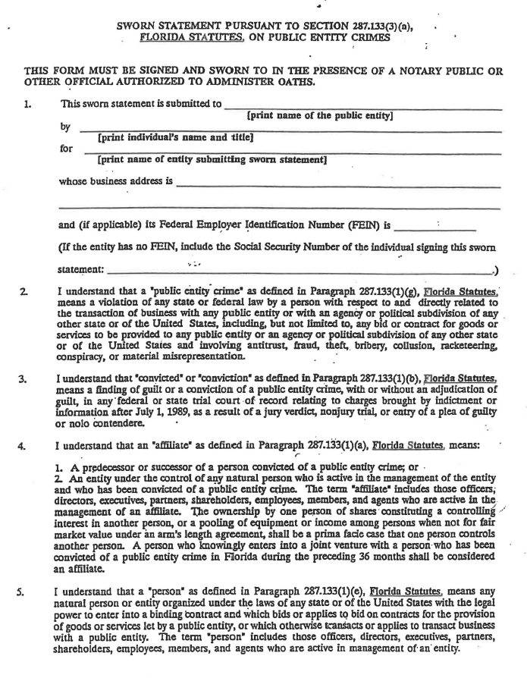
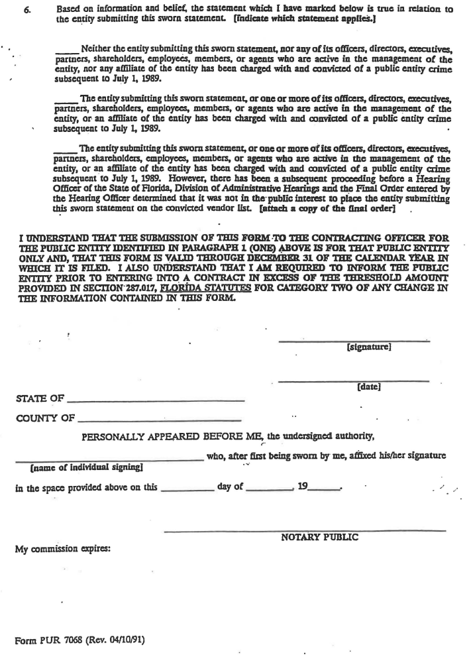
JESSICA LUNSFORD ACT:

The Jessica Lunsford act is a Florida law that requires fingerprinting and background checks of all individuals;
- Who are permitted access on school grounds when students are present,
- Who will have direct contact with children or any students of the School District, or
- Who will have access to or control of school funds

The Contractor for this project will have to meet the criteria listed in this section to be in compliance with this law. All personnel that will be on the school campus during this project will need to be fingerprinted and screened before any work can begin on the project. If any employees within your company have been fingerprinted and cleared by another agency, you will need to provide verification to the School Board of Levy County Personnel Department. For any employees that need to be fingerprinted, please contact the Personnel Department to schedule a mutually agreed upon time to have it done.
You can contact the Personnel Department at (352) 486 - 5231.

The cost of fingerprinting will be borne by the Contractor and the amount per person is $90.00. This fee includes $61.00 for the Florida Department of Law Enforcement (FDLE) and the Federal Bureau of Investigation (FBI). The $61.00 fee needs to be paid in advance with a Visa or MasterCard credit card or by bringing a money order made out to "Fingerprinting Services, LLC". Credit card payment can be made via the Internet at http ://www.flprints.com or by calling 877-357-7456. The remaining $29.00 needs to be paid at the time of fingerprinting. This will satisfy your requirement to be in compliance with this law and will cover the fingerprinted individuals for a period of 5 years.

As the person authorized to sign this statement, I certify that this firm will be in full compliance of this law while completing this project, as per the requirements listed above.

Authorized Representative (Signature)

Authorized Representative (Print Name) Title
Company Address

City, State and Zip Code Telephone Number

